PROJECT REPORT

ON

AIRLINE MANAGEMENT SYSTEM

*A Project report submitted*

*on partial fulfilment of the requirement for the*

**Diploma in Computer Science & Engg.**

**Submitted**

**By:-**

**GROUP-12 OF COMPUTER SCIENCE & ENGG.**

**SESSION (2020-2023)**

**Under the Guidance of**

0000000

Department of Computer Science & Engg.

**AL KABIR POLYTECHNIC JAMSHEDPUR**

**(A Unit of Kabir Welfare Trust)**

April 2023

**AL KABIR POLYTECHNIC JAMSHEDPUR**

**(A Unit of Kabir Welfare Trust)**

## CERTIFICATE

**TO WHOM IT MAY CONCERN**

### ***This is to certify that the project entitled on “REFIGERATROR BASED ON PELTIER EFFECT” has been submitted by Group No. 12. In partial fulfilment of the requirement for the award of the DIPLOMA IN MECHANICAL ENGINEERING. It is a bonafide of record carried out by them under our guidance & supervision.***

Ref. no:……………… Date……………….

|  |  |  |  |
| --- | --- | --- | --- |
| **SL. NO** | **NAME** | **ROLL NO** | **REG. NO** |
| 1 | Neelesh Gorai | ME/125/20 | 20404120125 |
| 2 | Nitin Prasad | ME/126/20 | 20404120126 |
| 3 | Nitish Kumar | ME/127/20 | 20404120127 |
| 4 | Nitish Kumar | ME/128/20 | 20404120128 |
| 5 | Owais Nazir | ME/129/20 | 20404120129 |
| 6 | Pankaj Kumar Mahato | ME/130/20 | 20404120130 |
| 7 | Prakash Mahato | ME/131/20 | 20404120131 |
| 8 | Purwa Kumari | ME/132/20 | 20404120132 |
| 9 | Rahil Sajid | ME/133/20 | 20404120133 |
| 10 | Rahmat Ali | ME/134/20 | 20404120134 |
| 11 | Raj Verma | ME/135/20 | 20404120135 |
| 12 | Rajiv Mahato | ME/136/20 | 20404120136 |
| 13 | Reem Hasib | ME/137/20 | 20404120137 |

**……………………………**

**Mr. ABDUL TAHIR KHAN**

**HOD cum LECTURER**

**(Dept. Of Mechanical Engg.)**

## CANDIDATE DECLARATION

We declare that this written submission “Refrigeration based on Peltier Effect” represents our ideas in our own words and where other or words have been included. We have adequately cited and referenced the original sources. We also declare that we have adhered to all the principles of academic honesty and integrity have not misprinted or fabricated or falsified any idea on our submission. We understand any violation of the above will be cause for disciplinary action by the institute and can also be evoke penal action from the sources which have not been properly cited or from whom proper permission have not been taken when needed.

|  |  |  |  |  |
| --- | --- | --- | --- | --- |
| SL  No. | Name | Roll No. | Registration No. | Signature |
| 1 | Neelesh Gorai | ME/125/20 | 20404120125 |  |
| 2 | Nitin Prasad | ME/126/20 | 20404120126 |  |
| 3 | Nitish Kumar | ME/127/20 | 20404120127 |  |
| 4 | Nitish Kumar | ME/128/20 | 20404120128 |  |
| 5 | Owais Nazir | ME/129/20 | 20404120129 |  |
| 6 | Pankaj Kumar Mahato | ME/130/20 | 20404120130 |  |
| 7 | Prakash Mahato | ME/131/20 | 20404120131 |  |
| 8 | Purwa Kumari | ME/132/20 | 20404120132 |  |
| 9 | Rahil Sajid | ME/133/20 | 20404120133 |  |
| 10 | Rahmat Ali | ME/134/20 | 20404120134 |  |
| 11 | Raj Verma | ME/135/20 | 20404120135 |  |
| 12 | Rajiv Mahato | ME/136/20 | 20404120136 |  |
| 13 | Reem Hasib | ME/137/20 | 20404120137 |  |

## ACKNOWLEDGMENT

We would like to express our gratitude and our appreciation to all those who gave us the possibility to complete this report. A special thanks to our project guide Mr. Sumit S Minz, Dept. of Mechanical Engineering whose help, stimulating suggestions and encouragement, helped us to coordinate our project especially in writing this report.

We would also like to acknowledge with much appreciation the crucial role of the staff of Mechanical Laboratory, who gave the permission to use all the required machinery and the necessary material to complete this project “**Refrigeration based on Peltier Effect**”. Specially thanks to my teammates who helped us to assemble the parts and gave suggestions about the project. Last but not least, many thanks go to the Head of Department, Mr. A.T. Khan who has given his full effort to guiding the team in achieving the goal as well as his encouragement to maintain our progress in track.

We would like to appreciate the guidance given by our Principal Mr. W.S. Imam that has improved our presentation skill by their comments and tips.

**Content**

|  |  |  |
| --- | --- | --- |
| Chapter no. | Title | Page no. |
| 1. | **Introduction** | 1 |
| 2. | **Objective of work** | 2 |
| 3. | **Construction and Design** | 3-4 |
|  | * Design of Refrigerator * Steps in construction of refrigerator |  |
| 4. | **Working of project** | 5 |
| 5. | **Components used in project** | 6-8 |
|  | * Thermoelectric cooler * Thermoelectric cooler * Thermoelectric cooler |  |
| 6. | **Working and Fabrication**   * Working of peltier cooler   Peltier cooling with N-type semiconductor  Peltier cooling with P-type semiconductor  Peltier cooling with P&N-type semiconductor   * Fabrication of peltier cooler | 9-14 |
| 7. | **Performance parameters**   * power supply and temperature control * co-efficient of performance(cop) * Advantages | 15 |
| 8. | **Applications of peltier cooler** | 16 |
| 9. | **Cost parameters** | 17-18 |
|  | **Conclusion** | 19 |
|  | **Bibliography** | 20 |

**Abstract**

Refrigeration expending thermoelectric cooling methods have been in research for the past few decades due to its recompenses paralleled to a vapor-compression refrigerator is its lack of moving parts or circulating fluid, invulnerability to leaks, small size, and flexible shape. Likewise, portable refrigerators filled with refrigerants are a big hassle to carry around along with being dangerous. This portable mini refrigerator will be capable of cooling a soft-drink canister or multiple 200 ml bottles at its prototype size and based on the results, something finer can be constructed.

This attempt of us at fabricating an eco-friendly refrigerator without having to deal with the prospects of handling a dangerous refrigerant is quite affordable when mass-produced and can be installed in glove compartments of a car or a separate refrigeration compartment can be installed in a vehicle. Furthermore, these can be put into use in organizations by individuals as often as possible.

The concept of a Peltier module which is customarily used in electronic devices, to be used in a refrigeration device may be non-conventional but this is an attempt at reducing the use of refrigerants that contribute to the greenhouse effect and work out a way around them. Significant benefits of thermoelectric cooling systems are that they have no moving parts. This lack of mechanical wear and abridged instances of failure due to fatigue and fracture from mechanical vibration and stress increases the lifespan of the system and lowers the maintenance requirements

**Chapter 1**

**Introduction**

Refrigeration is the process of heat-removal from a space in order to bring it to a lower temperature than surrounding temperature. In this context, my seminar topic, **“Peltier cooling module”** which works on thermoelectric refrigeration, aims to provide cooling by using thermoelectric effects rather than the more prevalent conventional methods like ‘vapour compression cycle’ or the ‘vapour absorption cycle’.

There are three types of thermoelectric effect: The Seebeck effect, the Peltier effect, the Thomson effect. From these three effects, Peltier cooler works on the Peltier effect; which states that when voltage is applied across two junctions of dissimilar electrical conductors, heat is absorbed from one junction and heat is rejected at another junction.

Peltier coolers are basically used as a cooling element in laser diodes, CCD cameras (charge coupled device), blood analysers, portable picnic coolers laser diodes, microprocessors, blood analysers and portable picnic coolers.

### **Chapter 2**

### **Objective of work**

The objective of this seminar work is to analyze the working of Peltier cooler. Scope of this work includes:

* Study of the principles and working of Peltier refrigerator; working parameters, performance parameters of the same.
* Exploring methods to improve the efficiency of the Peltier cooling systems and study the advancement in the field of thermoelectric.
* Studying new heat sink designs, which improves the performance of the Peltier cooler.

**Chapter 3**

**Construction and design**

3.1. Dimensions of refrigerator

1. Outer Dimensions:
2. Length: 62 cm
3. Breadth: 39 cm
4. Height: 21 cm

1. Inner Dimensions:
2. Length: 49 cm
3. Breadth: 30 cm
4. Height: 15 cm
5. Volume: 5 Litres.

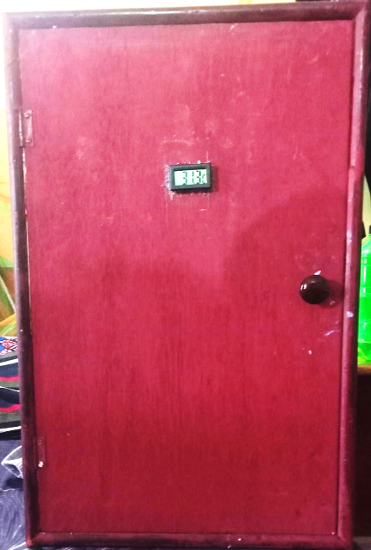

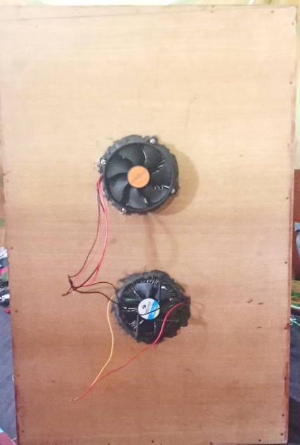

3.2. Steps in the construction of the refrigerator:

* Firstly a wooden box was made of given dimension and then the inner walls of the box are covered with the thermocol and aluminium sheet.
* The two peltier unit are well placed in the two holes made in the box and keep of the heat sink with hot side attached to the heat sink surface and cold side inside the box.
* The heat sink is linked with a fan which is used to dissipate the heat of heat sink into the outer atmosphere i.e. out of the thermocol box. So, the hot side of peltier unit is unable to affect the temperature inside the box.
* All the electrical connections are made putting a switch for on / off and a LED as an indicator whether the fridge is working or not. Two batteries of 12 volts DC,7 Ah are connected in series with the peltier units connected in series and the two cooling fans.
* All the electrical connections are made strong by soldering them and all the wires are arranged properly so as to avoid any inconvenience for the user.

### 

### **Chapter 4**

### **Working of the project**

1. The refrigerator is connected to the power supply from a 12volt DC 7 Ah battery.

2. To start the refrigerator the switch on it is turned on.

3. When the switch is turned on a LED stars glowing indicating that refrigerator is now on.

4. Now two peltier thermoelectric device which are insulated from the cooling side and arrange in the refrigerator to generate cooling effect on inner side and heat is dissipated on outer side.

5. On the heat side of the peltier unit a heat sink along with the fan works to dissipated the heat from the unit in the outer environment.

6. The peltier thermoelectric device will be arranged in the box with proper insulation system and heat sink so that efficient cooling takes place at all the time.

7.To turn off the refrigerator, switch can be turned off. Then the glowing LED will also stop glowing indicating no power for the refrigerator.

**Chapter 5**

**Components used**

In this project, we have used the following components:

**5.1. Thermoelectric cooler**

Semiconductor devices that use the peltier effect to a heat flux between the junctions of two materials. When an electric current is passed through a circuit of

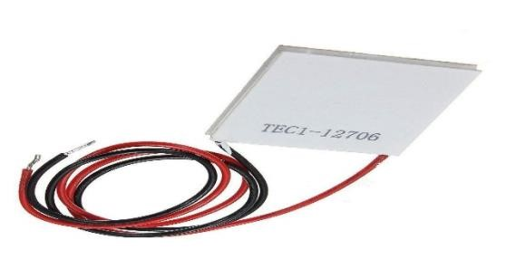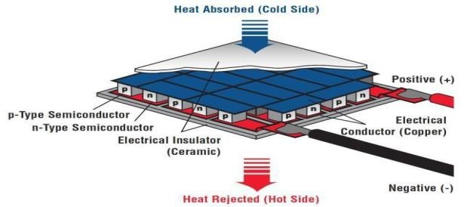

**Fig 1**: A Thermoelectric cooler

a thermocouple, heat is evolved at one junction and absorbed at the other junction. This is known as the Peltier Effect. When an electric current is passed through a circuit of a thermocouple, heat is evolved at one junction and absorbed at the other junction. This is known as the Peltier Effect.

**5.2. Peltier effect**

A temperature differential is created when a direct current is applied across two materials.

When DC current is applied to the circuit, the thermoelectric module can work as a cooler.

Thermoelectric cooler transfers heat from one side of the device to the opposite side against the temperature gradient.

Thermoelectric cooler provides a very simple and reliable cooling solution. However its poor thermal performance prevents wide usage.

Compared with traditional refrigeration systems, A TEC’s performance is only about 1/5th of a refrigeration cycle system.

**5.3. Battery**

Battery of 12V and 7Ah is used for running the peltier refrigerator.

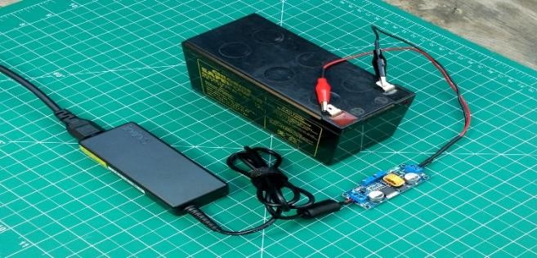

**Figure 2:** 12volts battery

**5.4. Heat Sink**

A heat sink is a component that increases the heat flow away from a hot device. It accomplishes this task by increasing the device's working surface area and the amount of low-temperature fluid that moves across its enlarged surface area. In this project we have used an active heat sink.

Active heat sinks utilize forced air to increase fluid flow across the hot area. Forced air is most commonly generated by a fan, blower, or even movement of the entire object―such as a motorcycle’s engine being cooled by the air passing along the heat sink fins designed into the engine. One example of a fan producing forced air across a heat sink is the fan in your personal computer turning on after your computer gets hot. The fan forces air across the heat sink, which allows more unheated air to move across the heat sink surface, thus increasing the total thermal gradient across the heat sink system and allowing more heat to exit the overall system.

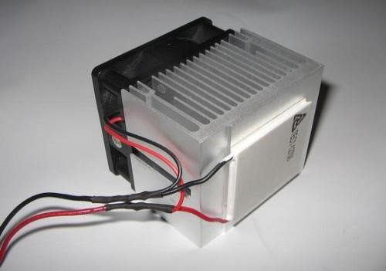

**Figure 3:** Heat sink

**5.5. CPU Cooling Fan**

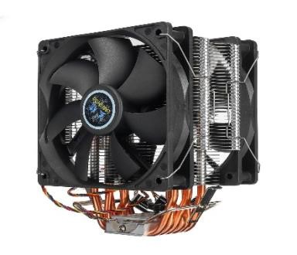The basic thermodynamic principle behind CPU cooling is convection. A hot object transfers some of its heat to the air molecules near its surface, cooling slightly in the process. If the air is moving, then these heated molecules will float away, allowing cooler air to replace them and absorb more heat.

**Figure 4:** cooling fan

After whole assembly of thermoelectric peltier refrigeration units

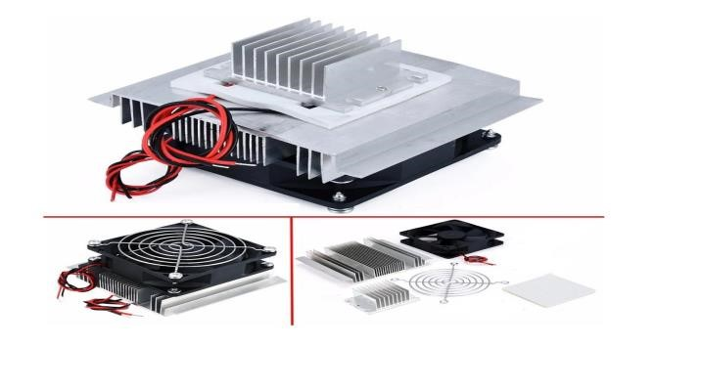

**Figure 5:** a cooling kit

In this Kit cooling fan and Heat sink is included, The bigger the heat sink, the greater dissipation of the heat.

The fan, in this kit, acts as a radiator. This is attached to the bigger heat sink.

**Chapter 6**

## Working and Fabrication

## 6.1. Working of Peltier cooler

The Peltier effect occurs whenever electrical current flows through two **dissimilar conductors**; depending on the direction of current flow, the junction of the two conductors will either absorb or release heat. In the world of thermoelectric technology, **semiconductors** are the material of choice for producing the Peltier effect because they can be more easily optimized for pumping heat. Using this type of material, a Peltier device (i.e., thermoelectric module) can be constructed in its simplest form around a single semiconductor “pellet” which is soldered to electrically-conductive material on each end (usually plated copper). In this configuration, the second dissimilar material required for the Peltier effect, is actually the copper connection paths to the power supply.

It is important to note that the heat will be moved in the direction of charge carrier movement throughout the circuit (actually, it is the charge carriers that transfer the heat).

### **6.1.1.** Peltier cooling with N-type semiconductor

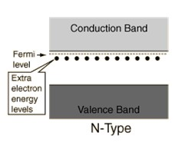 In Figure 5, “N-type” semiconductor material is used to fabricate the pellet so that electrons (with a **negative** charge) will be the charge carrier employed to create the bulk of the Peltier effect. As shown infigure below, N-type semi-conductor has an extra electron in its Fermi level (higher energy level).

##### **Figure 6:** N-type semiconductor Energy band diagram

With a **DC voltage source** connected as shown, electrons will be repelled by the negative pole and attracted by the positive pole of the supply; due to this attraction, electrons at Fermi level move towards positive terminal by releasing heat and creating the holes in the Fermi level. Now,

due to continuous supply of current, electrons move from valance band (lower energy band) to Fermi level by absorbing energy from the junction. With the electrons flowing through the N-type material from bottom to top, heat is absorbed at the bottom junction and actively transferred to the top junction. [10]

So we can say that, in Peltier cooler using N-type of semiconductor, heat is absorbed at the junction near negative terminal and heat is rejected at the junction near positive terminal.

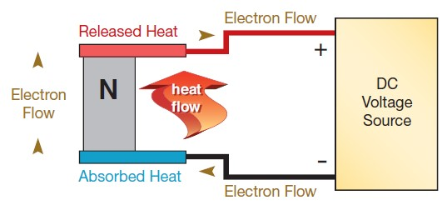

**Figure 7:** Peltier cooling with N-type semiconductor

### **6.1.2** Peltier cooling with P-type semiconductor

In the thermoelectric industry, “P-type” semiconductor pellets are also employed. Figure 8 shows the energy band diagram of P-type semiconductor. In this, holes are at the Fermi level (higher energy level).

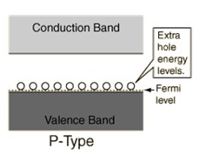

##### **Figure 8:** P-type semiconductor Energy band diagram

Now, when DC current is applied through the circuit as shown in Figure 9; holes get attracted towards negative terminal of source. By this attraction, holes move to negative terminal by releasing heat. Due to continuous supply of current, holes from conduction band moves to Fermi level by absorbing heat from the junction.

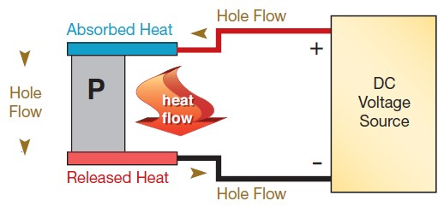

##### **Figure 9:** Peltier cooling with P-type semiconductor

So, we can say that, in Peltier cooler using P-type of semiconductor, heat is absorbed at the junction near positive terminal and heat is rejected at the junction near negative terminal.

### **6.1.3** Peltier cooling with P & N type of semiconductors

By arranging N and P-type pellets in a “couple” (see Figure 10) and forming a junction between them with a plated copper tab, it is possible to configure a series circuit which can keep all of the heat moving in the same direction. As shown in the illustration, with the free (bottom) end of the P-type pellet connected to the positive voltage potential and the free (bottom) end of the N-type pellet similarly connected to the negative side of the voltage.

As we have seen in previous section, for N-type of semiconductor, heat is absorbed from the junction near to the negative terminal and heat is releases at the junction near to the positive terminal. For P-type of semiconductor, heat is absorbed from the junction near to positive terminal and released at the junction near to negative terminal.

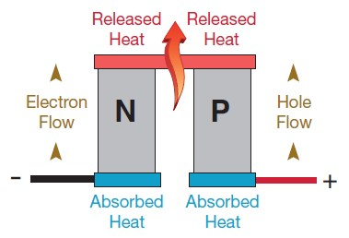

##### **Figure 10:** Peltier cooling by couple of N&P

##### 

By arranging the circuit as like in Figure 10, it is possible to release heat to the one side and absorb from another side. Using these special properties of the TE “couple”, it is possible to team many pellets together in rectangular arrays to create practical thermoelectric modules as in Figure 11.

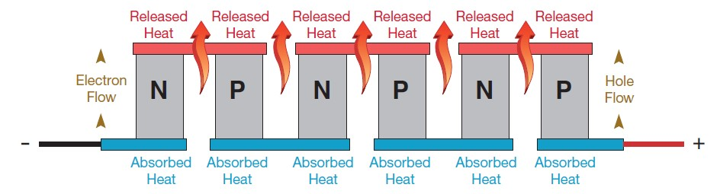

**Figure 11:** Peltier cooling by multiple pallets

## 6.2. Fabrication of Peltier cooler

As we have seen in previous section, for producing thermoelectric effect couples of P and N type semiconductors are connected in series by metal plates. By doing this it absorbs the heat from one side and releases the heat to another side.

So, when solid state P-N materials are connected electrically in series and thermally in parallel it makes one thermoelectric unit as shown in Figure 12.

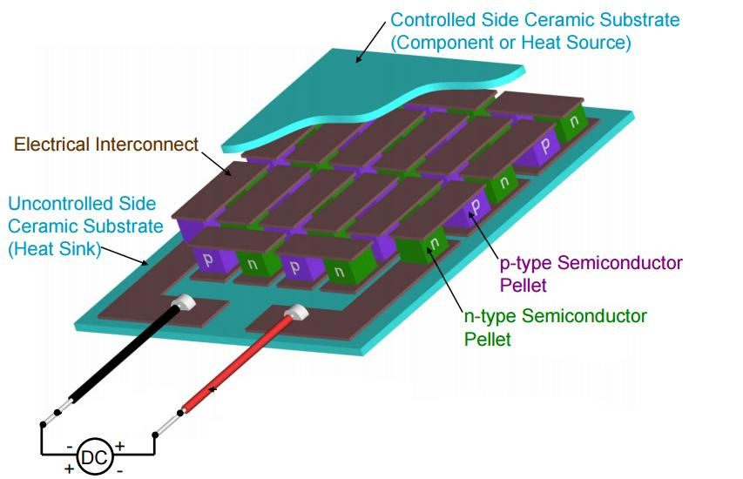

#### **Figure 12:** Fabrication of Peltier module

A typical TEC module comprises of two highly thermally conductive substrates (A12O3, AlN, BeO) that serve as Hot/Cold plates. An array of p-type and n-type semiconductor (Bi2Te3, Sb2Te3, Bi2Se3, PbTe, Si-Ge) pellets are connected electrically in series sandwiched between the substrates. The device is normally attached to the cold side of the TEC module, and a heat sink which is required for enhanced heat dissipation is attached to the hot side. Solder is normally used to connect the TEC elements onto the conducting pads of the substrates. The construction of a single stage thermoelectric module is shown in Figure 12.

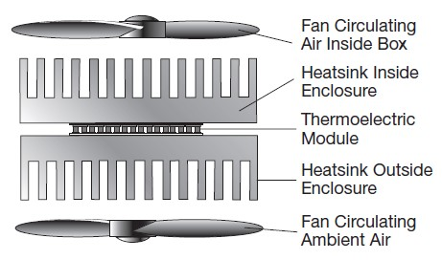Considering a typical thermoelectric system designed to cool air in an enclosure (e.g., picnic box, equipment enclosure, etc.) as in Figure 10; this is probably the most common type of TE application. Here the challenge is to “gather” heat from the inside of the box, pump it to a heat

**Figure 13:** Configuration of air-to-air thermoelectric cooler

exchanger on the outside of the box, and release the collected heat into the ambient air. Usually, this is done by employing two heat sink/fan combinations in conjunction with one or more Peltier

devices. One of the heat sinks is used on the inside of the enclosure; cooled to a temperature below that of the air in the box, the sink picks up heat as the air circulates between the fins. In the simplest case, the Peltier device is mounted between this “cold side” sink and a “hot side” sink. As direct current passes through the thermoelectric device, it actively pumps heat from the cold side sink to the one on the hot side. The fan on the hot side then circulates ambient air between the sink’s fins to absorb some of the collected heat. Note that the heat dissipated on the hot side not only includes what is pumped from the box, but also the heat produced within the Peltier device itself (V x I).

Let’s look at this in terms of real numbers. Imagine that we have to pump 25 watts from a box to bring its temperature to 3oC from 20oC (ambient). To accomplish this, we might well have to take the temperature of the cold side sink down to 0° C. Using a Peltier device which draws 4.1 amps at 10.4 V, the hot side of the system will have to dissipate the 25 watts from the thermal load plus the 42.6 watts it takes to power the TE module (for a total of 67.6 watts). Employing a hot side sink and fan with an effective thermal resistance of 0.148 C°/W. The temperature of the hot side sink will rise approximately 10°C above ambient. It should be noted that, to achieve the 17° C drop between the box temperature and ambient, we had to create a 30° C (54°F) temperature difference across the Peltier device.

### **Chapter 7**

### **Performance parameters**

### **7.1.** Power Supply and Temperature Control

Power supply and temperature control are two added items that must be considered Wisely for a successful TE system. TEC is a direct current device. The quality of the DC Current is important. Current and voltage of a TEC can be determined by the charts Provided by the manufacturer. TEC’s power is the product of required voltage and Current. (P = IV).

Temperature control is generally categorized into two groups. One is open loop or

Manual and the other is closed loop or automatic. For cooling systems normally cold Side is used as basis of control. The controlled temperature is compared to the ambient Temperature. An on-off or a control using thermostat is the simplest and easiest Techniques to control the temperature of a TEC.

**7.2.** Coefficient of performance (C.O.P)

The quantity of greatest importance for a refrigerator is the coefficient of performance (COP), which is defined as the ratio of the heat extracted from the source to the expenditure of electrical energy. If the thermocouple were free of losses associated with heat conduction and electrical resistance, the COP It requires low maintenance cost.

**7.3.** Advantages

1. It is low in cost, so it affordable and have essential features.
2. Low electricity consumption; make it economical in term of service too.
3. This project contains a solution of the energy crisis.
4. It has a great engineering impact that we can make you of the mechanical energy for heating, Cooling or vice versa. So, it gives a big use of the law of energy transformation

**Chapter 8**

**Applications of peltier cooler**

* Thermoelectric cooling is used in medical and pharmaceutical equipment, spectroscopy systems, various types of detectors, electronic equipment, portable refrigerators, chilled food and beverage dispensers, and drinking water coolers.
* Requiring cooling devices with high reliability that fit into small spaces, powerful integrated circuits in today's personal computers also employ thermoelectric coolers.
* Using solid state heat pumps that utilize the Peltier effect, thermoelectric cooling devices are also under scrutiny for larger spaces such as passenger compartments of idling aircraft parked at the gate. Some of the other potential and current uses of thermoelectric cooling are:
* **Military/Aerospace**

Inertial Guidance Systems, Night Vision Equipment, Electronic Equipment Cooling, Cooled Personal Garments, Portable Refrigerators

* **Consumer Products**

Recreational Vehicle Refrigerators, Mobile Home Refrigerators, Portable Picnic Coolers, Wine and Beer Keg Coolers, Residential Water Coolers/Purifiers.

* **Industrial Equipments**

C Computer Microprocessors, Microprocessors and PCs in Numerical Control and Robotics, Medical Instruments, Hypothermia Blankets, Pharmaceutical Refrigerators - Portable and Stationary, Blood Analysers, Tissue Preparation and Storage, Restaurant Equipment, Cream and Butter Dispensers.

**Chapter 9**

**Cost parameters**

9.1. Amount Collected

|  |  |  |  |
| --- | --- | --- | --- |
| Sl No. | Name | Roll no. | Amount |
| 1. | Neelesh Gorai | ME/125/20 | Rs. 1000 |
| 2. | Nitin Prasad | ME/126/20 | Rs.1000 |
| 3. | Nitish Kumar | ME/127/20 | Rs. 1000 |
| 4. | Nitish Kumar | ME/128/20 | Rs. 1000 |
| 5. | Owais Nazir | ME/129/20 | Rs. 1000 |
| 6. | Pankaj Kumar Mahato | ME/130/20 | Rs. 1000 |
| 7. | Prakash Mahato | ME/131/20 | Rs. 1000 |
| 8. | Purwa Kumari | ME/132/20 | Rs. 1000 |
| 9. | Rahil Sajid | ME/133/20 | Rs. 1000 |
| 10. | Rahmat Ali | ME/134/20 | Rs. 1000 |
| 11. | Raj Verma | ME/135/20 | Rs. 1000 |
| 12. | Rajiv Mahato | ME/136/20 | Rs. 1000 |
| 13. | Reem Hasib | ME/137/20 | Rs. 1000 |

9.2. Amount Spent

|  |  |  |  |
| --- | --- | --- | --- |
| Sl. No. | Components | Quantity | Amount (Rs.) |
| 1. | Wooden box | 1 | 1950 |
| 2. | Glue gun | 1 | 300 |
| 3. | Battery | 1 | 810 |
| 4. | Peltier kit | 2 | 950 |
| 5. | CPU Fan | 2 | 750 |
| 6. | Aluminium foil | 1 | 90 |
| 7. | Thermocol | 5 | 180 |
| 8. | Glue fun refill | 4 | 60 |
| 9. | Wires | 2 | 25 |
| 10. | Heat sink | 2 | 180 |
| 11. | Blower | 2 | 170 |
| 12. | Thermal paste | 2 | 60 |
| 13. | Thermometer probe | 1 | 150 |
| 14. | Tape | 1 | 20 |
| 15. | M seal | 5 | 50 |
| 16. | Fence | 1 | 30 |
| 17. | Fevicol | 1(250gm) | 90 |
| 18. | Switch & LED | 1,1 | 75 |
| 19. | Battery pins | 4 | 25 |
| 20. | Extra charges |  |  |

**Conclusion**

Since Peltier cooling is not efficient comparatively and due to its small size applications, it is not widely used. It found its application only in electronics cooling etc. But we have seen that there is a huge scope of research in this field about thermoelectric materials, its fabrication, heat sink design etc. Researcher are working on reducing irreversibilities in the systems, because Peltier cooler has more potential which we can see from the vast difference between value of first law efficiency and second law efficiency.

**References**

1. [http://www.melcor.com](http://www.melcor.com/)
2. [**www.hyperphysics.phy-astr.gsu.edu/**](http://www.hyperphysics.phy-astr.gsu.edu/)
3. <https://www.sciencedirect.com/>
4. <https://en.m.wikipedia.org/wiki/Main_Page>
5. <https://en.m.wikipedia.org/wiki/Thermoelectric_effect>